Highcliffe School Student Bulletin

Tuesday 3rd - Friday 6th October 2006: Week A

Thought For The Week:
Aspire not to have more, but to be more (Oscar Romero)

News Story of the Week:
Girl sees again with donated eyes
See http://news.bbc.co.uk/cbbcnews/hi/world/default.stm
for more details and other news stories!

Bookies Book Club: Our next meeting is on Wednesday 4th October at 1.45pm in the library. We welcome all year groups and would like to see some year 7's coming along. Refreshments are available, so bring yourself, a book and a friend and we'll see you there!

Music Clubs:
Tuesday lunchtime: Keyboard Club in EX2 1.40-2.10pm
Tuesday after school: Harmonious Funk Jazz Band in EX3 3.20-5.00pm
Wednesday lunchtime: SHOUT! Vocal Group in EX3 1.40-2.10pm
Thursday lunchtime: Theory Workshop EX2 1.40-2.10pm
Thursday after school: Auditions for this year’s Musical (Prearranged only) in EX2 3.20-5.00pm

Thank you to all who attended the launch of this year’s Musical last Wednesday. If you wish to take part and haven't signed up, you need to see Mr. Trevorrow as soon as possible.

Ski Trip – Dry slope lessons:
Choice 2 starts on wed 4th October. Please aim to arrive from 6.00pm in order to have time to get boots on etc! Ready to start at 6.30pm. Don't forget your gloves!! To check which group you are in before you go pop over to Ma3.

Tesco's Sport Vouchers: Please bring any Tesco Sports vouchers you have collected to the Library. The collection box is on the Library desk. The more vouchers we collect, the more sports equipment we can obtain for the school.

Fantasy Football: It’s back bigger and better then ever! £70 million to make your team. This season you can make transfers each month and the competition is open to staff, students AND NOW parents.
To enter, bring £3.50 to Mr Gutteridge in room Ma4 before Friday 6th October. All entrants receive a mini football. Go on. You know you want to!

Message for Year 9 students - If you took part in the pottery workshop during Activities Week in July, please attend a glazing workshop in At15 to complete your clay self-portrait. The workshops will take place on Monday 9th and Tuesday 10th October. Please see Miss Deery for more details.

If you find that your teacher is absent for a sixth form lesson, please go to the sixth form study room where the supervising teacher will register you electronically. The work from that teacher will be available for you, on the notice board.

Merits – Don’t forget – merits can be cashed in on Monday, Thursday & Friday lunchtimes in the Library, 1.45pm-2.15pm!

Come along! We will be making and racing balloon cars in S-Factor this Thursday 5th October, after school!

Sports Results:


Year 10 rugby v Ballard - won
Year 8 football v Arnewood (County cup) - won
Year 9 netball v Ferndown - won
Year 11 netball v Ferndown - lost
Year 9 netball v Priestlands - won
Year 9 netball v Ringwood - won
Year 10 rugby v Grange - won
Year 7 girls’ football v Grange - lost
Year 8 girls’ football v Grange - won
Year 7 girls’ football v Twynham - won
Year 8 girls’ football v Twynham - lost
Years 10/11 girls’ football v Grange - drew

Brain food (prizes to be won!!):
The answer to last week’s question:

Henrik Stenson holed the winning putt on the final day of the Ryder Cup to ensure a European victory!

Congratulations to Ryan Taylor (7.5) who needs to see Mr Yapp to collect his prize!

This week’s question:
Name the artist and the name of this painting:

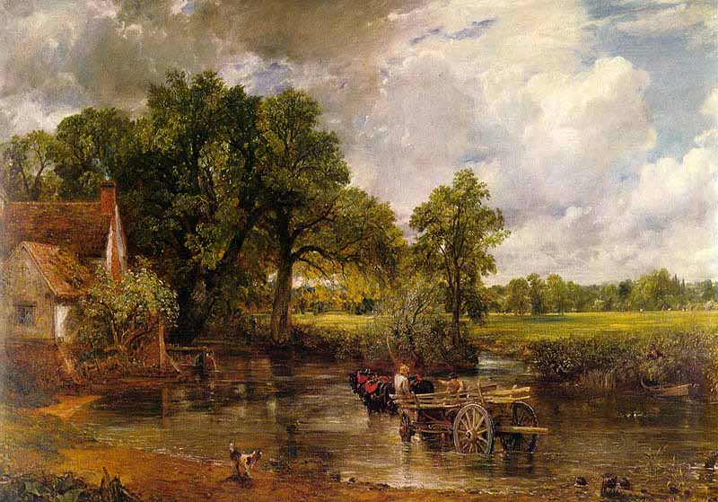

If you think you know the answer, write it down, together with your name & tutor group and post it into the box in the library. You could be a winner!

